Lab2:Search algorithms

Task1:Path planning algorithm

Uninformed search: BFS and DFS

The bfs and dfs search algorithm will visit every possible path it have until it reaches the goal.it is more time consuming

Informed search: A_star algorithm

The A_star algorithm comes into the category og informed search. It just minimize the number of nodes it has visited.It is less time consuming to find the path.

There are two categories in A_Star:

1. Eucledian distance: It is the sum of the squares of the distance between start and end point the path of Euclidean is always right_angles.
2. Manhattan distance: It is the sum of the absolute values of start and end point the path will be in a straight line

Random search: In my random search I took moving cost from one node to another node randomly.

Without inverted H obstacle:

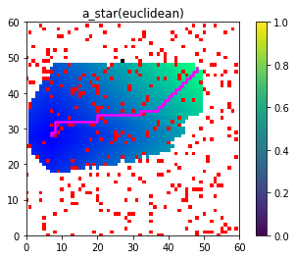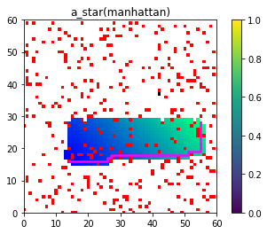

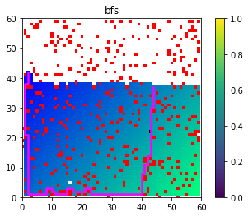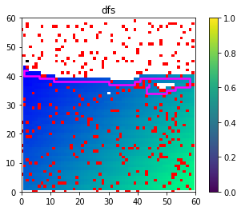

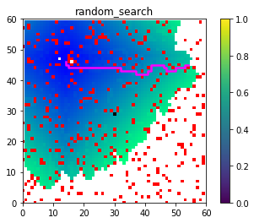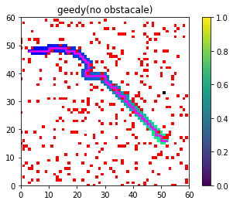

With inverted H obstacle:

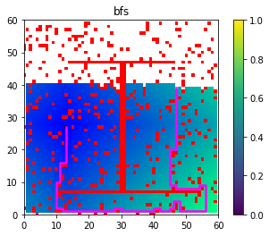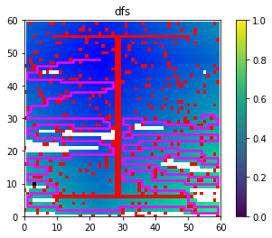

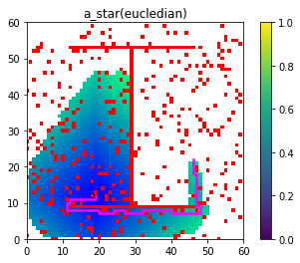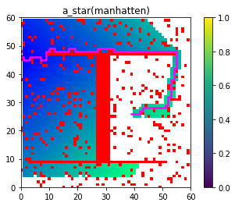

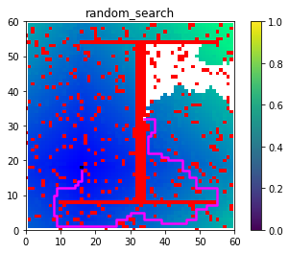0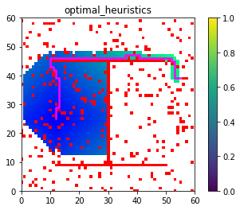

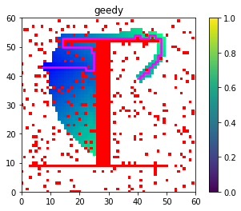

Task2:Poker Bidding search using search algorithms

Here the we need to find the optimal sequence of actions so that the agent can will all the time by using search algorithms(BFS,DFS,A_Star) and more ever we should atleast 100 coins within 4 hand .

There are 5 different stages for each state there are call ,fold , bet5,bet10,bet25

The algorithm will run continuously until the showdown(call) state occurs

BFS(first in first out):

I used normal Queue in my bfs to find my optimal path .

Output:

************* state info **************

nn_current_hand 4

nn_current_bidding 0

phase SHOWDOWN

pot 0

acting_agent agent

parent_state <__main__.GameState object at 0x0000028CDEBDC288>

children None

agent <__main__.PokerPlayer object at 0x0000028CFA4FD948>

opponent <__main__.PokerPlayer object at 0x0000028CFA4FD808>

---------- showdown ----------

Greedy Search:

In greedy search by taking the heuristics to minimize the path . and the moving cost is taken as strength of the current hand and bidding value.

Random search:

In random search I took the moving cost as randomly.